# Experimental Report

## CP1N3-24721015 李鹏麒

# **所属内容：Experimental N3-C1-20241023**

# **完成部分说明：编写算法与代码、调试与测试、撰写实验报告**

**The programme language**: C language

**The programming platform**: Visual Studio 2022

**Program function**:

(1)Input any lowercase English letter from the keyboard and output its sequence number in the alphabet.

(2)Determine the type of characters entered from the keyboard, such as numbers, letters, or other special characters.

(3)Find the sum of even factorials from 1 to 9, that is, find 2+ 4! + ... +8!.

**Program algorithm**:(Specific code is in the folder)

(1) To get the character inputted, we need to use the function “char” to read the letter from the keyboard, and use the correspond “%c” to print the digit of the verity. Using the “if” to judge whether the input is a lowercase English letter. Using the ‘’ to transform the letter to the number in the alphabet.

1. To let the user have a comfortable using experience, using the “while” to let the program keep running without getting out and getting in again and again. Then use the “if”, ”else if”, ”else” to take every possible type into consideration, and “&&” to size the broaden of the “ch”.
2. Using function “for” to number from 1 to 9, using “%2” to calculate the left number and judging it with 0 using “==” to examine if it is an even number, using if to sum all the even with “+=”.

**Program flow chart:**

(1)Input any lowercase English letter from the keyboard and output its sequence number in the alphabet.

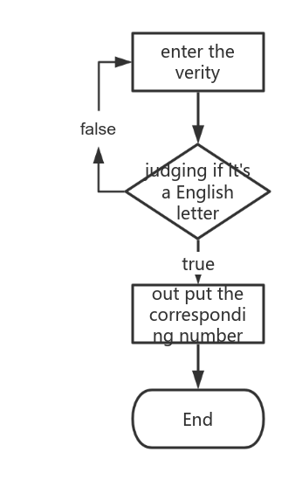

1. Determine the type of characters entered from the keyboard, such as numbers, letters, or other special characters.

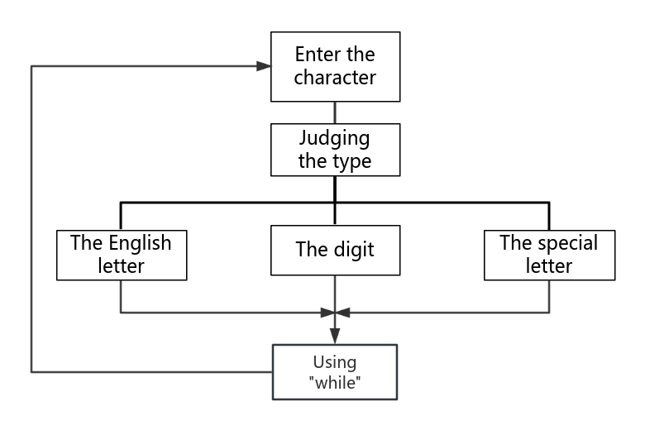

(3)Find the sum of even factorials from 1 to 9, that is, find 2+ 4! + ... +8!.

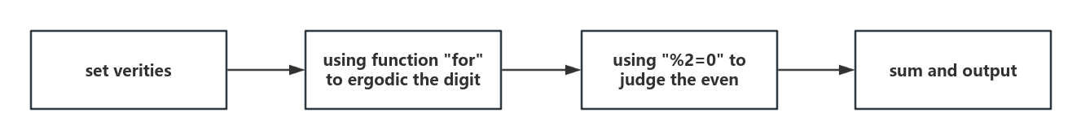

**Program experiment test:**

(1)Using the function “get char()” to solve the buffer problem.

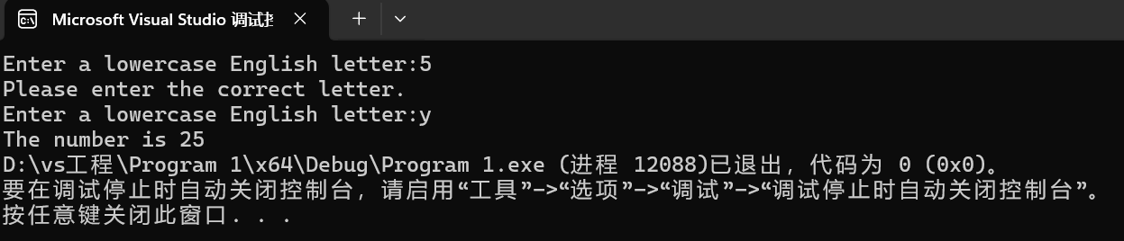

(2)Using “while” to keep it running.

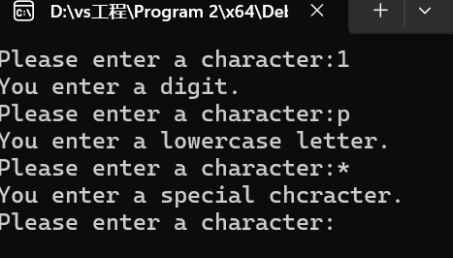

1. We could reedit input the broaden if we want it to have more using places.

